Homemade spectroscope
This is an activity for students to create their own spectroscope to observe the diffraction of light and compare light spectra from a range of sources.
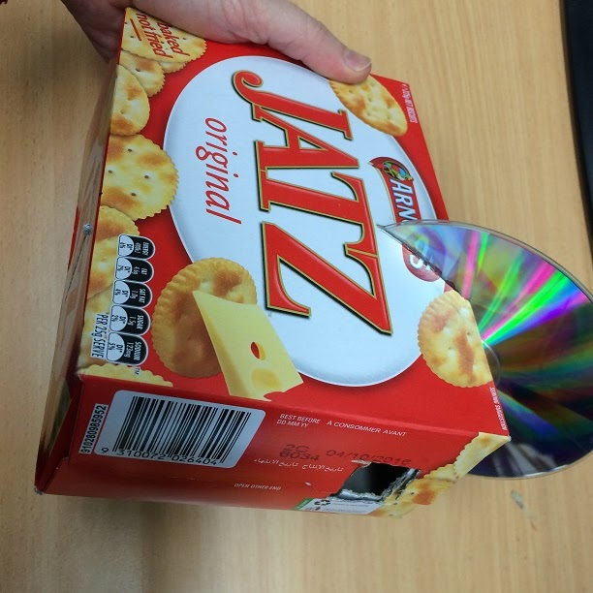

Equipment:
- Box (e.g. biscuit or cereal box)
- Marker pen
- Ruler
- Craft knife (may need teacher’s assistance)
- Old CD (or DVD) that is no longer needed

Method:
- Use the marker pen and ruler to mark where you will cut holes in the box as pictured below:
  - CD slit, to hold the CD at an angle of 30°-45°
  - Narrow slit, directly opposite the CD
  - Viewing hole, directly above the CD, approximately 2 cm x 2 cm in size

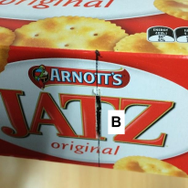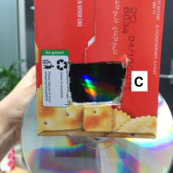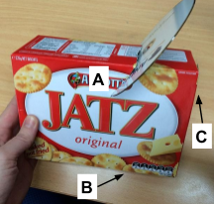

- Use the craft knife to carefully cut the holes and slits as marked.
- Slide the CD into the angled slit with the reflective side facing the viewing hole.
- Point the narrow slit towards a light source (e.g. fluorescent light) and change the position slightly until a clear spectrum appears on the CD when viewed through the viewing hole.

Note: A cleaner edge can be made for the narrow slit by cutting a wider hole and covering it with a narrow slit made using aluminium foil or cardboard held in place with sticky tape.

Extension:
- Use the spectroscope to look at different sources of light e.g. hydrogen lamp, helium lamp and neon lamp and compare the different spectra.

Adapted from: https://www.youtube.com/watch?v=ZowYVDQDDZ4

