Measuring the speed of light
This investigation uses a microwave oven to calculate the speed of light by measuring the wavelength of a microwave radiation using an egg white. This can be done by using chocolate or cheese slices instead of egg whites.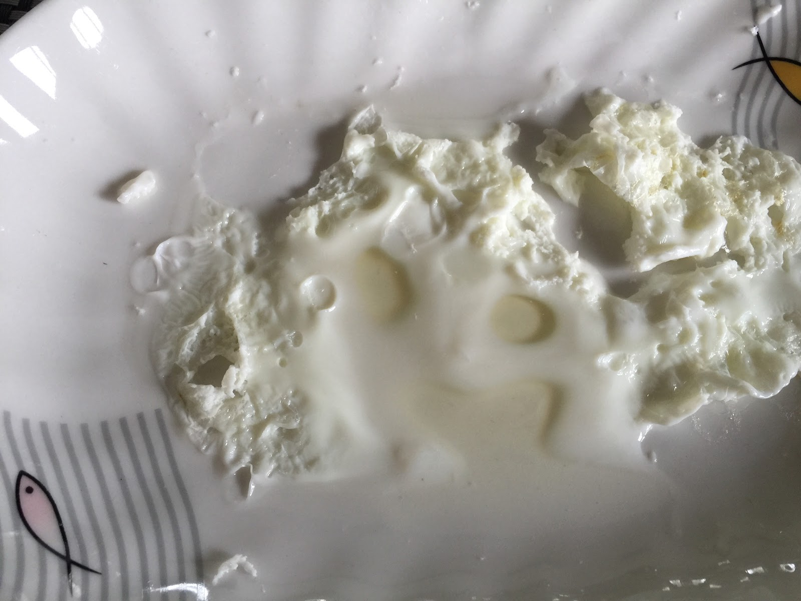

Equipment:
- 1 × microwave oven
- 1 × microwave safe plate (width > 20 cm)
- 1 x microwave safe bowl (larger than the drive mechanism inside the microwave)
- 1 × egg
- 1 × 30 cm ruler
- 1 × pair of oven mitts

Method:
- Remove the rotating platter and the drive mechanism for the turntable inside the microwave oven. If it is not possible to remove the drive mechanism, place a flat-bottomed microwave safe bowl upside-down over the drive mechanism.
- Crack the egg and separate the egg white from the yolk. Pour the egg whites onto the microwave safe plate - make sure the egg spreads out to at least a 12 cm diameter.
- Place the egg white and plate into the microwave oven. If you are using the bowl, carefully place the plate on top of the upside-down bowl.
- Set the microwave power to medium and the time to 15 seconds. Press start and, watching the whole time, stop the microwave when the egg white is partially cooked in some places and completely cooked in other places.
- Use the oven mitts to remove the plate from the microwave oven, being careful not to disturb the position of the egg white on the plate. Allow the plate and the egg white to cool.
- Measure the centre-to-centre distance between two adjacent cooked areas. This is the ½ of the wavelength of the microwave radiation produced by the microwave oven.
- Measure the shortest and longest edge-to-edge distances between two adjacent cooked portions.
- Look at the label on the back of the microwave oven or the user’s manual to find the frequency of the microwave radiation produced by the microwave oven.
- Calculate the speed of the microwave radiation using the wave equation: v=f. Calculate the error using the shortest edge-to-edge distance (lower boundary) and longest edge-to-edge distance. Compare the results to the actual value of speed of light.

Adapted from:
Science Buddies: Hands-on Science Resources for Home and School
http://www.sciencebuddies.org/science-fair-projects/project_ideas/Phys_p056.shtml#procedure

